Dopa

For Memory Trainer Application

Version 2.0

Revision History

|  |  |  |  |
| --- | --- | --- | --- |
| **Date** | **Version** | **Description** | **Author** |
| 12/07/2015 | 2.0 | Initial Creation | Linganesan |

|  |  |  |
| --- | --- | --- |
| **TABLE OF CONTENTS** | |  |
| **1.** | **INTRODUCTION** | **4 - 5** |
| 1.1 | Purpose | 4 |
| 1.2 | Scope | 4 |
| 1.3 | Overview | 4 |
| 1.4 | Reference Material | 4 |
| 1.5 | Definitions and Acronyms | 5 |
| **2.** | **SYSTEM OVERVIEW** | **5** |
| **3.** | **SYSTEM ARCHITECTURE** | **6 – 10** |
| **4.** | **DATA DESIGN** | 11 |
| 4.1 | Data Description | 11 |
| 4.2 | Data Dictionary | 11 |
| **5.** | **COMPONENT DESIGN** | **12** |
| **6.** | **HUMAN INTERFACE DESIGN** | **12** |
|  |  |  |
|  |  |  |
|  |  |  |
|  |  |  |
|  |  |  |

**1. INTRODUCTION**

**1.1 Purpose**

This is a memory trainer application. As the name implies this application is designed for the purpose of enhance the memory power by applying ingrain Method of loci strategy as a mnemonic technique. User can create their own mind palace and it will be saved in a database. User will able to practice with his/her mind palace and also can view his/her specific profiling to know their improvements.

The purpose of this document is to provide detailed design specification of the memory trainer application. It provides the high-level and low-level design decisions of the android mobile application.

**1.2 Scope**

This document describes the detailed design of the project. The mobile application architectures and the interfaces are explained in this document. This document describes all the data, architectural, interface and component-level design for the application. It also provides explicit information about the requirements for the application and how the application is to be put together.

**1.3 Overview**

This document is created according to the IEEE standards for design documentation and some changes are made in order to make it more suitable for the android application. This section gives an introduction to this design specification document. It describes the purpose and scope of this document. Section two, system overview gives description of the functionality, context and design of the project. Section three, provides the details of the system architecture. Section four, five and six provides details about the data design, component design and human interface design of the android application

**1.4 Reference Material**

1. *http://en.wikipedia.org/wiki/Software_design_description*

**1.5. Definitions and Acronyms**

|  |  |
| --- | --- |
| Android application | Mobile software application developed for use on devices powered by Google's Android platform |
| Interface | A shared boundary across which information is passed. |
| User | Someone who uses the system |
| RUP | Rational Unified Process |
| SDS | Software Design Specification |
| GUI | Graphical User Interface |
| UI | User Interface |
| MVC | Model View Controller |

**2. SYSTEM OVERVIEW**

This is a memory trainer application. A mnemonic is any device that aids memory. In order to improve memory, we need a systematic way of committing items to memory. Important use cases of this application are Creation and maintenance of a mind palace, able to practice using memory palace, view user specific profiling and keep remember notes using memory palace.

The main functional requirements of this android mobile application are follows.

* Creation and maintenance of a mind palace
* Able to Practice using memory palace
* User specific profiling
* Keep remember notes using memory palace

This application has no limited targeted customer in focus, from children to elders anyone can use this app. So user friendly design is also taken as the important consideration as this is an android application, all the designs adhere to the standard android design guidelines. The user interface is made simple and as intuitive as possible.

**3. SYSTEM ARCHITECTURE**

**3.1 Architectural Design**

Based on the requirements analysis, the application’s components, modules, interfaces and interactions of the system modules with other modules have been designed. This chapter describes the System architecture diagram, Use case diagram, Class diagram and State diagrams of this application.

**Systems Architecture Diagram**

The user input is a touch even captured by the application which simulates the game logic module. The audio and graphics module includes the creation of the images and production of appropriate sounds.

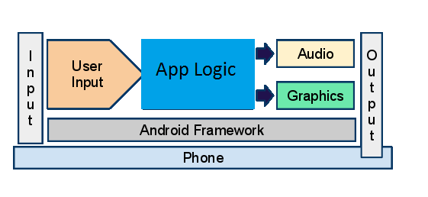

Model-View-Controller architecture is used for the design of the application architecture, since it can be easily handled in Android. MVC supports flexibility by separation of responsibilities.It helps separate the input logic, the application logic and the UI. The following diagram is the simplest logical representation of the model view controller concept.

**MVC architecture diagram**

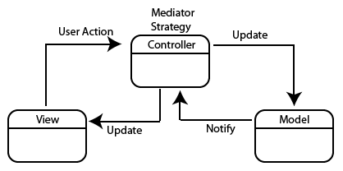

In this model the application is divided into 3 separate components called model, view and controller. They are interconnected. Controller controls overall application. View get the support from model and controller in order to output to the user. Model is used to save the temporary data of the application.

1. User clicks/taps somewhere on the screen.
2. The controller handles the click/tap and converts the event into an appropriate action
3. The controller updates the model‘s state accordingly.
4. The view gets notified about the state changes and renders current state.

**Use Case Diagram**

A Use Case diagram is used to represent the actions by the user in a system. It has roles and actions. Each user/role has different privileges and each perform different actions. For the application, there is only one user and the user can do the below actions:

1. Enter the Game
2. View Instructions
3. Create and maintain a mind palace
4. Practice using mind palace
5. Keep notes using mind palace
6. View specific profiling
7. Mute/Unmute Background Music
8. Save Scores
9. Check Menu options
10. Play other games
11. Go to Home screen

The actions the user can do in this application are shown in the below use case diagram.

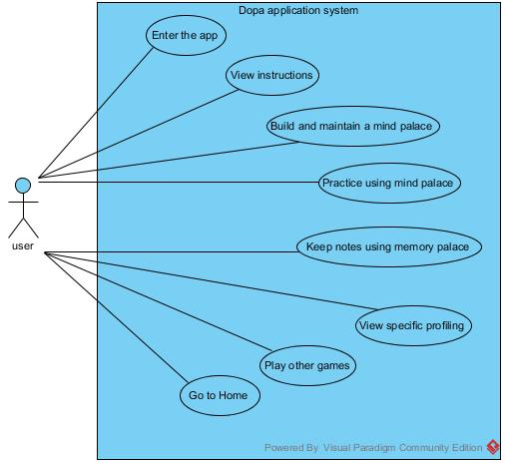

**Class Diagram**

A class diagram shows the basic types being built in the system. It forms a prototype for the application being developed and encompasses the classes, fields, methods and the relationship between these classes. The main structure of this game application can be represented by the following class diagram.

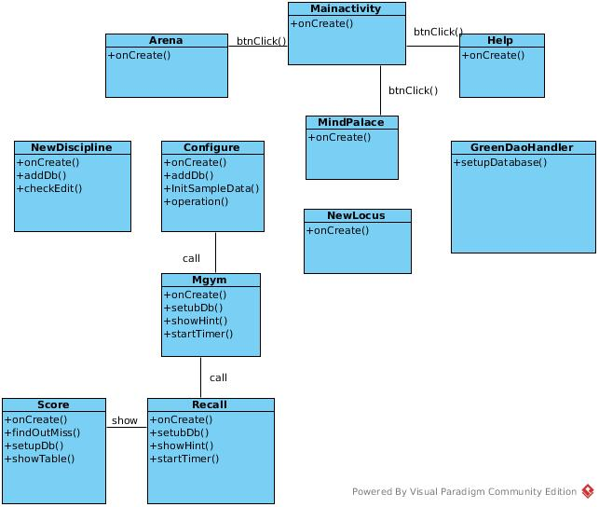

**4. DATA DESIGN**

**4.1 Data Description**

The major information saved in this application is memory palace details. During the start-up of the application user required to build a memory palace and details are saved. Initially this data is saved in the MindPalace object of the application and subsequently these details are saved in the database which is hosted outside the application. During a practice session user can be request to view his/her memory palace, in order to memorize the words given in the session.

**4.2 Data Dictionary**

Main entities of this application are

1. User entity
2. Mind Palace entity

Main functions in this application are

1. Create/Edit a Mind palace
2. Use Mind Palace
3. User Profiling

For the create mind palace function inputs will be the some places details which are received from the users as the user input. Use mind palace function will be called in practice session and when user want to memorize notes according to his/her mind palace. For the user profiling function, the progress is updated as input during the end of a practice session or other games which are played by user.

ER diagram

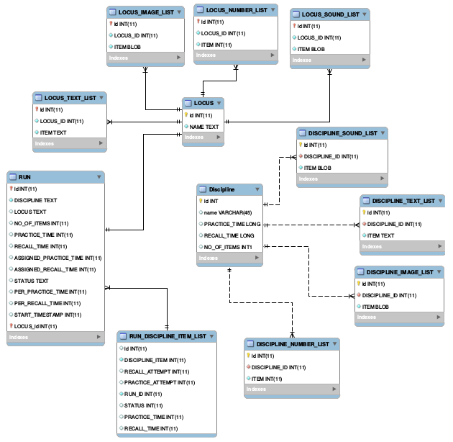

**5. COMPONENT DESIGN**

For the create mind palace user function it does not require any specific algorithm. This function will receive the user inputs and it will be stored temporarily and after that it will be stored permanently in the database. Use mind palace function gets the mind palace details as the user input. User profiling function call updates when user played a session and then it will show the overall progress to the user.

**6. HUMAN INTERFACE DESIGN**

**6.1 Overview of User Interface**

The user interface is made simple and as intuitive as possible. “Keep it Simple” was the motive behind out UI design. The number bubbles are made big enough to aid easy navigation on smart phones and hence various sized drawable images are included to support different device configurations. Consistent layout with easy navigation and simple instructions ensures understandability. Attractive User Interface is very essential for any game application.

1. Decorative fonts are used in the start screen and all over the application.
2. Bright and attractive colors and contrasting color combinations are used in background.
3. Instead of having 2D objects embedded into Canvas renderer, translucent gradient images that gives a 3D illusion.

When the user clicks the application icon in the android mobile, the user will initially see the splash screen. After a few seconds the user will see a screen which have four buttons, one button is mind palace(can build or edit) and the second button is m-gym(practice session) third button is study hall(Theory section) and the fourth button is progress.